Scenario Name
Write the scenario you have chosen here | Search Functionality
Weak Prompt
Copy the weak prompt from the scenario card above | "Test the search feature."
What I Feel is Missing
List the gaps you identified in the weak prompt | 1. What needs to be searched not given (product,book, sport, which domain/entity) - Very vague prompt and no specific information  2. No limitations given (color, type, information)  3.
IInstruction
What exactly do you want the AI to do? | Want to test the search feature for a iphone that has memory over 512 GB and above
CContext
What is the application, environment, or domain? | BestBuy application
EExample
Give one sample test case or scenario as a reference | Give the list of Iphone models that has Memory over 512 GB. Color should be Blue/Pink.  List out the model, year of release, memory spec, amount in dollar, and any offers
PPersona
Who is the AI acting as? (e.g., Senior QA Engineer) | Senior QA Engineer
OOutput Format
How should the output be structured? (Table, Gherkin, numbered list) | Give the output in the table format
TTone
Formal, Technical, Simple — who is the audience? | The output should be simple - even a nontech person should understand.
✅ Rewritten Prompt
Combine all ICEPOT components into your final prompt here | Consider myself as a Senior QA Engineer. I am looking for Iphones that has memory of 512 GB and above in BestBuy website.  The color of the phone should be in blue/pink. Provide the details in table in the following format - the model, year of release, memory spec, amount in dollars, and any others (new, refurbished, etc). The output should be simple and not much technical details needed.

Weak Prompt output 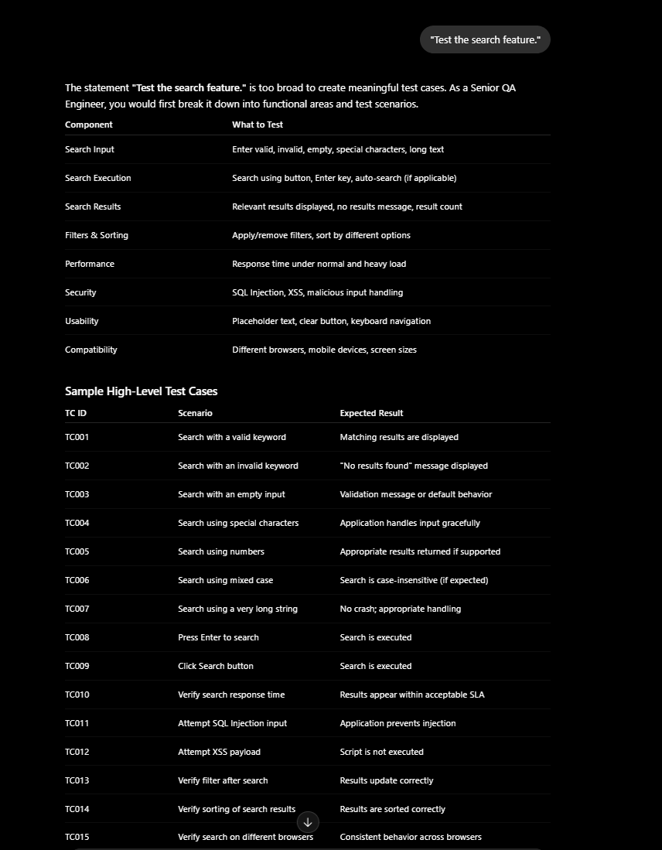

ICEPOT FORMAT Result
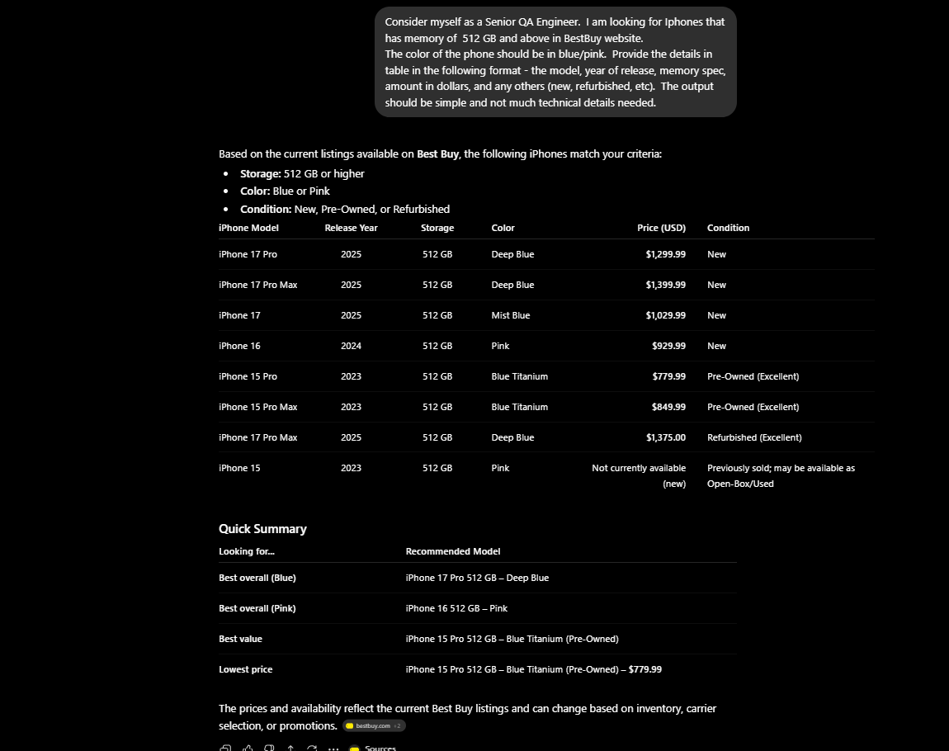

OBS - Write your first observation on what improved in the output

The output is of desired format which listed out the make, color, storage and price. In the prompt, I specifically requested to provide other details which listed out if the phone is Preowned, new, refurbished, unlocked, open box and also asked to list out specific color to ensure search is working as per requirement.

CASE -2 – File Upload
Scenario Name
Write the scenario you have chosen here | File Upload
Weak Prompt
Copy the weak prompt from the scenario card above | "Generate test cases for file upload."
What I Feel is Missing
List the gaps you identified in the weak prompt | Missed where it needs to be uploaded, type of file to be uploaded, supported file types (jpg, png, txt), max size of file that is supported for uploaded, error scenarios to check for uploading big file size, corrupt file, file with long file name, corner test cases to attempt uploaded small and big file sizes , format of the test cases (Test case No, Scenario, Test Data, Expected behavior, Result, Remarks), whether downloadable format is expected, uploaded exe file, malicious files.
IInstruction
What exactly do you want the AI to do? | Need test cases for file uploaded, url - https://practice.expandtesting.com/upload,  Supported file - jpeg. Jpg and nonsupported files - png, txt, maximum upload size - 5 MB, confirmation message post successful upload, error scenarios while uploading nonsupported file type and relevant error message, exceeding max file size, including corner cases to upload with small size, long file name, special characters in file name.
CContext
What is the application, environment, or domain? | url - https://practice.expandtesting.com/upload
EExample
Give one sample test case or scenario as a reference | Format of the test cases (Test case No, Scenario, Test Data, Expected behavior, Result, Remarks)
PPersona
Who is the AI acting as? (e.g., Senior QA Engineer) | Consider as Senior Test Lead
OOutput Format
How should the output be structured? (Table, Gherkin, numbered list) | List out in table format, should be downloadable in excel format
TTone
Formal, Technical, Simple — who is the audience?
✅ Rewritten Prompt
Combine all ICEPOT components into your final prompt here
Consider the role as Senior Test Lead.
Need test cases for file uploaded, url - https://practice.expandtesting.com/upload,
Supported file - jpeg. Jpg and nonsupported files - png, txt, maximum upload size - 5 MB, confirmation message post successful upload, error scenarios while uploading nonsupported file type and relevant error message, exceeding max file size, including corner cases to upload with small size, long file name, special characters in file name. Add cases for boundar value analysis, malicious file upload, multiple file uploads, performance test cases. Format of the test cases (Test case No, Scenario, Precondition, Test Data, Expected behavior, Result, Test Priority, Automation Candidate, Remarks), give the result in excel downloadable format

Weak Prompt output 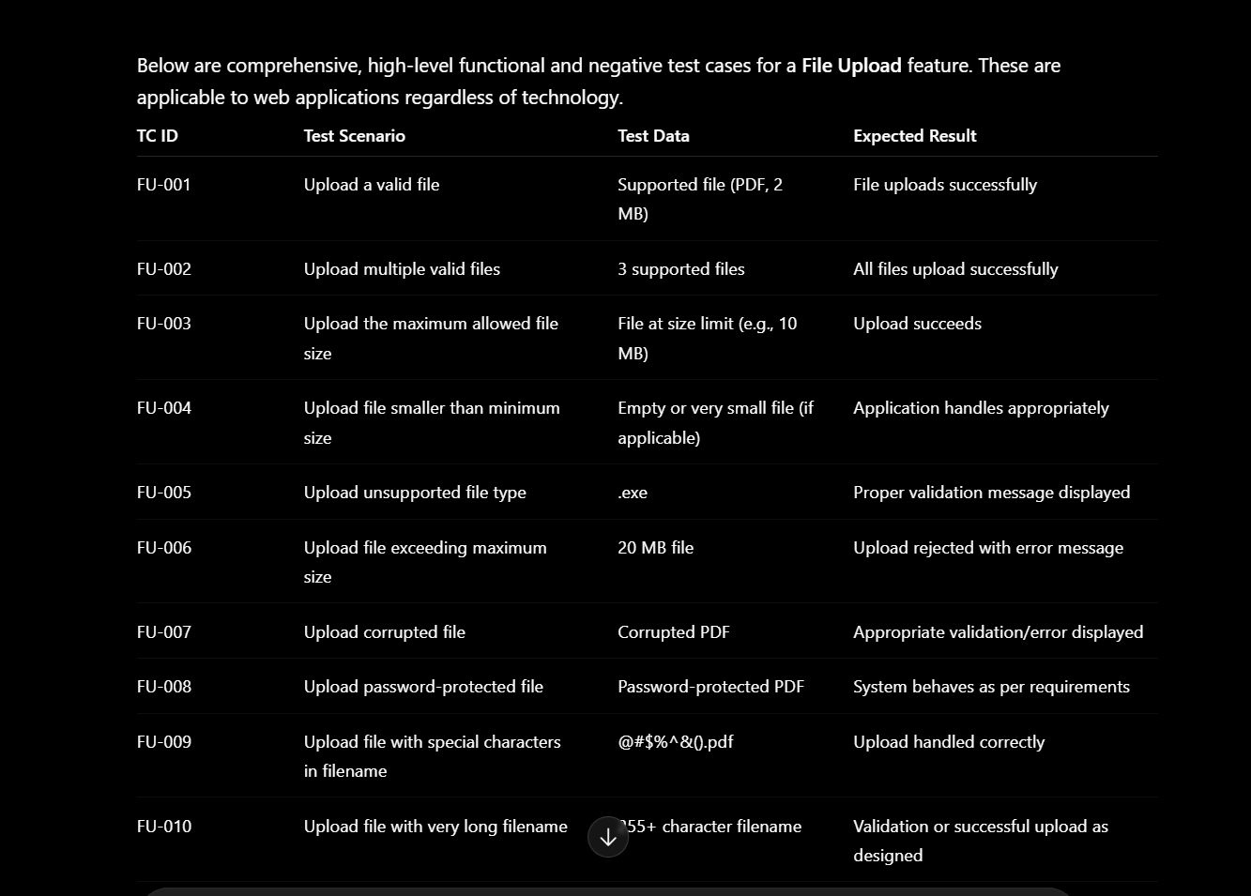

ICEPOT Format Result
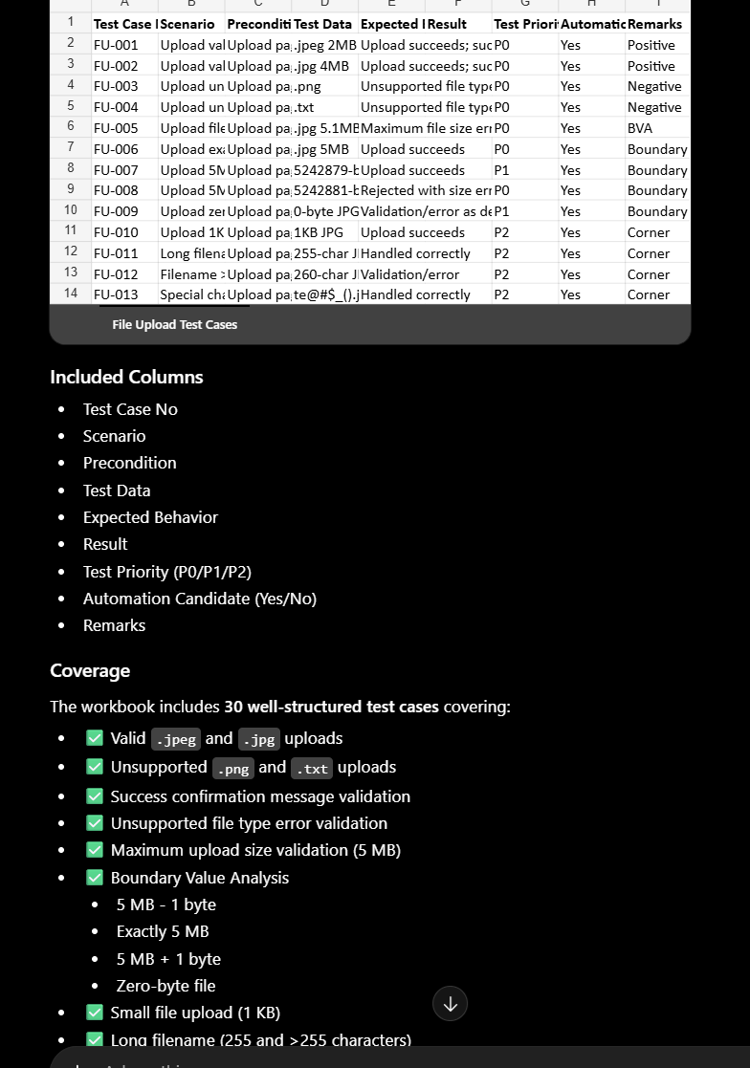
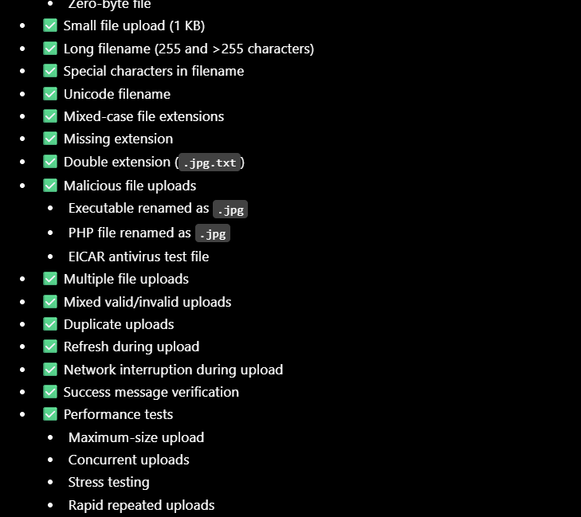

OBS - Write your first observation on what improved in the output

Detailed test coverage is observed in ICEPOT Format. The output is of desired format and can be downloaded as given in the prompt.

CASE 3- DASHBOARD/REPORT Generation

Scenario Name
Write the scenario you have chosen here | Dashboard / Report Generation
Weak Prompt
Copy the weak prompt from the scenario card above | "Test the reports section."
What I Feel is Missing
List the gaps you identified in the weak prompt | No detailed information given on what domain, what kind of report is expected on that domain, types of report, date filters, function based filters, link checks, check if the report can be downloaded locally, give the long range date filter and validate, any chart based report based on the filters
IInstruction
What exactly do you want the AI to do? | Need a business report to understand the number of visitors for Georgia Aquarium. The report should have an option to see month wise visitors for the last 12 months. The report should list out date filters to see how many visitors have visited, classification on weekday/weekend visitors, busy months/dates based on filters. The report should also give out if the visitor count has increased/decreased thorugh symbols when compared to same month last year, last month this year. How many visitors from General Admission or Senior citizen admission
CContext
What is the application, environment, or domain? | Georgia Aquarium
EExample
Give one sample test case or scenario as a reference
 | The report should have classification filters (date range, weekday/weekend visitors), should list out visitor count increase/decreased when compared to same month previous year and last month, same year and should list the increase/decrease symbols. There should be a separate section to each month visitor in bar chart format and should high the busy months with color coding. Should have separate section to show visitors from General Admission/Senior citizen admission. Headings should be listed in each section
PPersona
Who is the AI acting as? (e.g., Senior QA Engineer) | Consider the role of Business Analyst
OOutput Format
How should the output be structured? (Table, Gherkin, numbered list) | The report should list top level metrics, comparision charts in Bar and Column, time series charts in Line, slicers/dropdowns to select the date range and classification
TTone
Formal, Technical, Simple — who is the audience? | Should be a professional report that can used for presentation
✅ Rewritten Prompt
Combine all ICEPOT components into your final prompt here
Create a comprehensive business intelligence report tracking Georgia Aquarium attendance patterns to drive operational insights and staffing alignment.Core Reporting Requirements and give the result in UI dashboard format.
Core Reporting RequirementsTemporal Trends: A rolling 12-month historical view displaying monthly attendance distribution. Filtering: Dynamic date slicers allowing stakeholders to isolate specific timeframes and drill down into daily counts.Operational Segmentation: Categorization of attendance figures comparing weekday vs. weekend foot traffic.Peak Period Analysis: Identification of high-volume dates and busiest months based on selected user filters.Period-over-Period Performance: Visual performance indicators (using trend symbols) evaluating current traffic against both the prior month and the same month from the previous year.Demographic Breakdown: Ticket type segmentation isolating General Admission volume from Senior Citizen attendance counts.

Weak Prompt Output
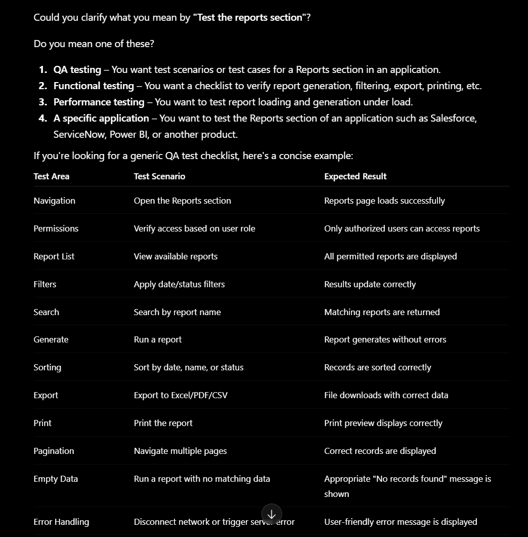

ICEPOT Format Output
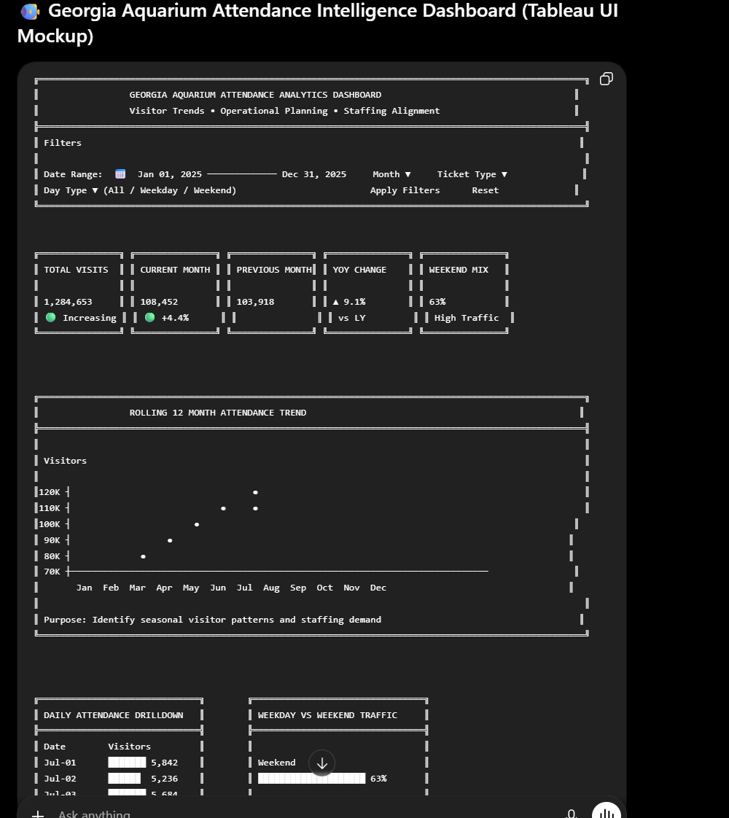
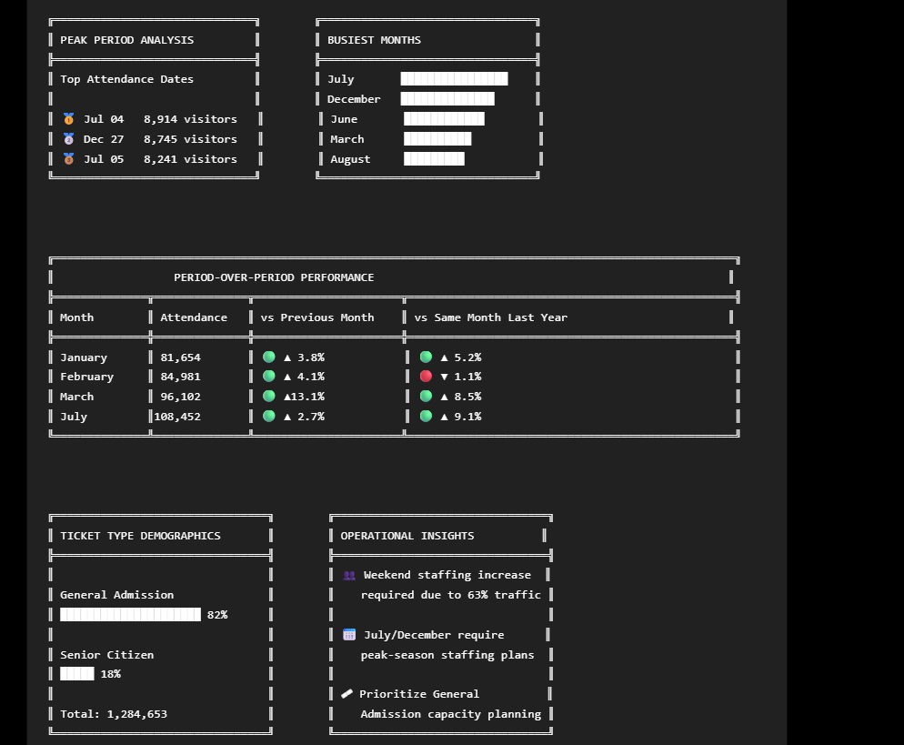
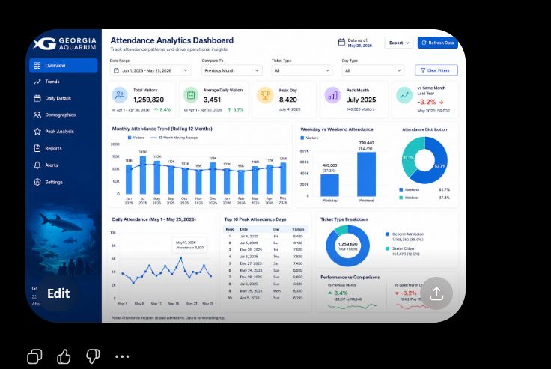

OBS - Write your first observation on what improved in the output

The report is very detailed with appropriate heads, filters, metrics and UI representation which gives detailed operational inisights required for the business.

